|  |  |
| --- | --- |
| |  | | --- | | INSTALLATION PROCESS  **POS-DB-DOC-Installation.docx** | |

Table of Contents

INSTALLATION PROCESS 1

Procedure Objective 2

Purpose/Scope: 2

References 2

Procedure steps 3

Employment 3

Pre-requisites 3

Start the PostgreSQL installation/remediation script 3

Detect the environment misconfiguration 4

Remediate/fix an environment 4

Installation/creation of a PostgreSQL database 7

Installation specificities 8

# Procedure Objective

## Purpose/Scope:

The Purpose of this document is to describe the PostgreSQL installation process in the SG environment.

# References

|  |  |
| --- | --- |
| Ref. No | Document Title |

# Procedure steps

## Employment

The script was developed to accomplish individual tasks like:

* Detect misconfiguration on the Unix server
* Remediate a fresh server to match with PostgreSQL SG requirements
* Create a PostgreSQL cluster

**Keep in mind that the client is able to create a full PostgreSQL server using SGCLoud. This documentation is not the preferred method to create a new PostgreSQL environment**

## Pre-requisites

In order to start the environment building, the following pre-requisites will be necessary

* The Unix server is matching with the SG Unix norms (svctools, normalized filesystems …)
* The PostgreSQL compkit/pupkit is applied on the server (check with your system administrator)

## Start the PostgreSQL installation/remediation script

|  |  |
| --- | --- |
| **Step** | **Description** |
| 1 | Connect on to the server were you want to operate using a ssh connection |
| 2 | Switch to **postgres** user (from your named DBA account)  sudo su – **postgres** |
| 3 | Call the installation script **pg_install.pl**  /opt/nfs/PostgresqlServer/Install/COM/pg_install.pl |
|  |  |

## Detect the environment misconfiguration

|  |  |
| --- | --- |
| **Step** | **Description** |
| 1 | Start the **pg_install.pl** program |
| 2 | Choose the “Pgsql Environment check” (action 1) |
| 3 | The program will display all the errors detected on the server |

## Remediate/fix an environment

|  |  |
| --- | --- |
| **Step** | **Description** |
| 1 | Start the **pg_install.pl** program |
| 2 | Choose the “Installation/Remediation of the Postgres environment” (action 2) |
| 3 | You have the choice to list the environment misconfiguration (action 1), remediate the misconfiguration with a prompt before each modification (action 2) and finally automaticvally remediate the environment (action 3) |
| 4 | The remediation execution display report with different sections:   * The remediation parameters (automatic remediation, no fix …)      * The list of remediation executed including the Unix command and the result code (with error messages in case of failure)      * A remediation summary with the total count of misconfiguration detected, the number of remediation executed with success and with errors |

## Installation/creation of a PostgreSQL database

|  |  |
| --- | --- |
| **Step** | **Description** |
| 1 | Start the **pg_install.pl** program |
| 2 | Choose the “Create a PostgreSQL database cluster” (action 4)  The program will guide you through different configuration screens |
| 3 | Choose the PGDATA parent directory from a list of suggested directory  The PGDATA directory of the cluster will be created in this directory |
| 4 | Choose the configuration options for the newly PostgreSQL cluster    **Postgresql binaries:**  List the Postgresql binaries available on the server. The software collection are use to provide the PostgreSQL engine so this least will always contains a single entry (only one version of binaries installed per server)  **Postgresql Cluster name:**  This name is mainly provided for inventoring purpose  A random name is suggested but it should be customized (using action 3)  **Cluster cache memory sizing (GB):**  The data cache size of the cluster.  You can choose between different predefined values, try to use most of the server memory (only one cluster installed on the server), try to use the free memory on the server ( multi cluster in the server) or defined a custom value  **Listen port:**  The listen port of the PostgreSQL cluster.  The Cluster is configured to listen on the Unix service (detected from the PGDATA parent directory path)  It should only modified in case of multiple PostgreSQL installed on the same service.  You can go on with the installation using the **S** choice. |
| 5 | List the installation choices and proceed with the installation  You can choose between creating the installation script or executing the PostgreSQL Cluster installation |

## 

## Installation post actions

Whenever you create a PostgreSQL Cluster, don’t forget to customize the configuration default values.

The **$PGDATA/postgresql.conf** must always be edited and customized regarding the client/application requirements

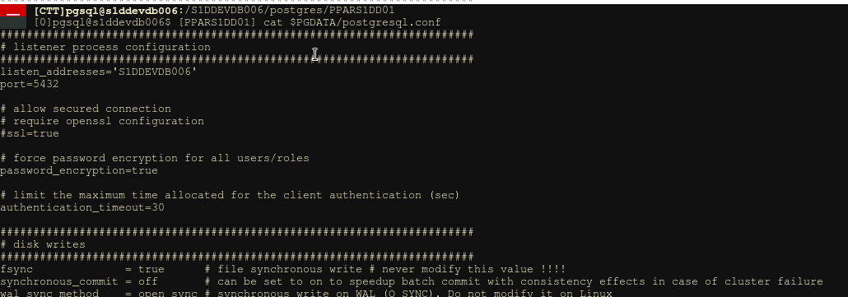

## Installation specificities

The PostgreSQL runtime user is **pgsql**

Each cluster is declared in the pgtab configuration file. There is one pgtab file for each Unix service (/<SVC>/postgresql/pgtab)

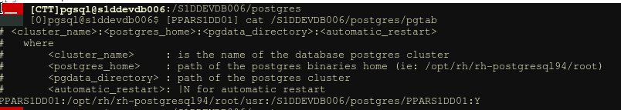

In this exemple:

* the cluster PPARS1DD01 is using **/opt/rh/rh_postgresql94/root/usr binaries** (part of RH software collection)
* The corresponding PGDATA is located in /S1DDEVDB006/postgres/PPARS1DD01
* The database will automatically stop/start based on the corresponding Unix SVC operations